**Wrapper Classes in Java**

A Wrapper class in Java is a class whose object wraps or contains primitive data types.

When we create an object to a wrapper class, it contains a field and in this field, we can store primitive data types. In other words, we can wrap a primitive value into a wrapper class object.

Let’s check on the wrapper classes in Java with examples:

**Need of Wrapper Classes**

There are certain needs for using the Wrapper class in Java as mentioned below:

1. They convert primitive data types into objects. Objects are needed if we wish to modify the arguments passed into a method (because primitive types are passed by value).
2. The classes in java.util package handles only objects and hence wrapper classes help in this case also.
3. Data structures in the Collection framework, such as [ArrayList](https://www.geeksforgeeks.org/arraylist-in-java/) and [Vector](https://www.geeksforgeeks.org/vector-vs-arraylist-java/), store only objects (reference types) and not primitive types.
4. An object is needed to support synchronization in multithreading.

**Note:**

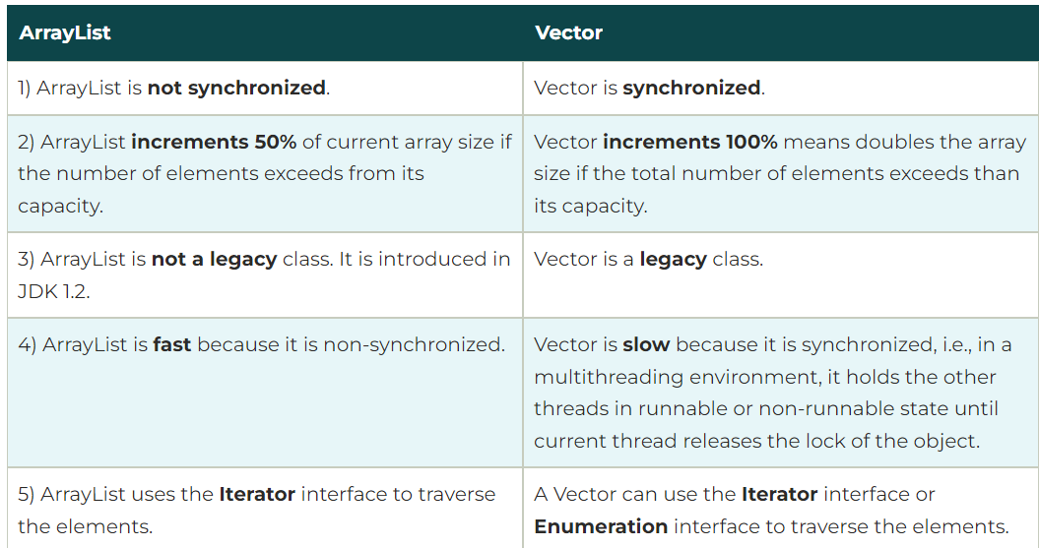

**Advantages of Wrapper Classes**

1. Collections allowed only object data.
2. On object data we can call multiple methods compareTo(), equals(), toString()
3. Cloning process only objects
4. Object data allowed null values.
5. Serialization can allow only object data. (Serialization is the process of converting an object into a byte stream for storage or transmission. **Advantage**: Only objects can be serialized. Wrapper classes enable primitive data types to be serialized by converting them into objects.)

**Primitive Data Types and their Corresponding Wrapper Class**

**8 in number.**

| **Primitive Data Type** | **Wrapper Class** |
| --- | --- |
| char | Character |
| byte | Byte |
| short | Short |
| int | Integer |
| long | Long |
| float | Float |
| double | Double |
| boolean | Boolean |

**Autoboxing and Unboxing**

1. **Autoboxing**

The automatic conversion of primitive types to the object of their corresponding wrapper classes is known as autoboxing. For example – conversion of int to Integer, long to Long, double to Double, etc.

**Example:**

*// Java program to demonstrate Autoboxing*

**import** **java.util.ArrayList**;

**class** **Autoboxing** {

**public** **static** void main(String[] args)

{

char ch = 'a';

*// Autoboxing- primitive to Character object*

*// conversion*

Character a = ch;

ArrayList<Integer> arrayList

= **new** ArrayList<Integer>();

*// Autoboxing because ArrayList stores only objects*

arrayList.add(25);

*// printing the values from object*

System.out.println(arrayList.get(0));

System.out.println(a);

}

}

**Output**

25

a

**Other ways:**

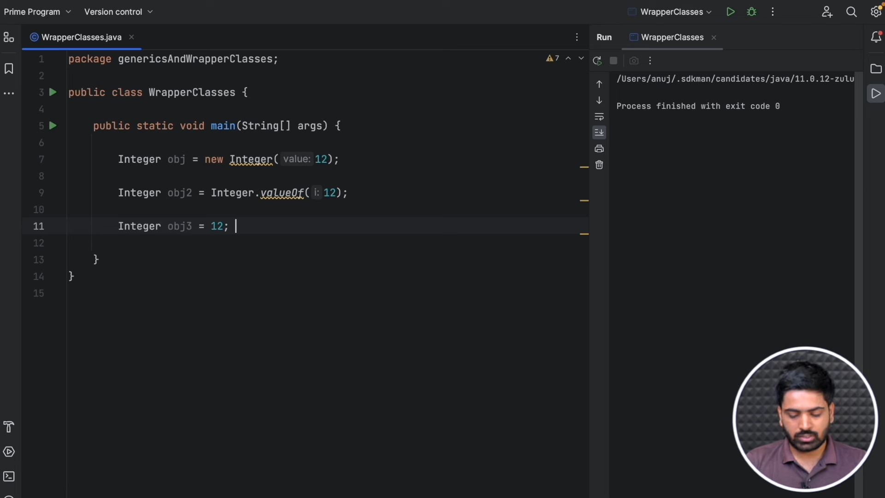

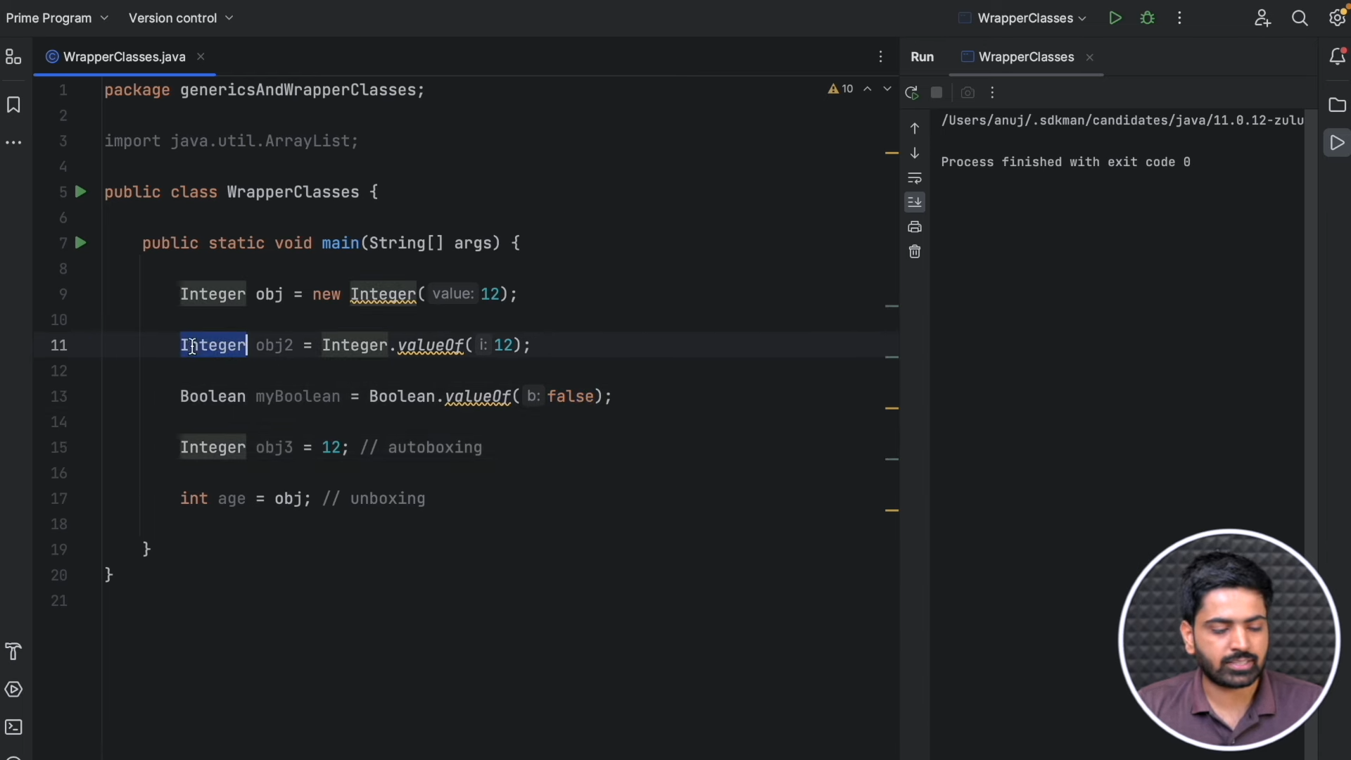

1. **Unboxing**

It is just the reverse process of autoboxing. Automatically converting an object of a wrapper class to its corresponding primitive type is known as unboxing. For example – conversion of Integer to int, Long to long, Double to double, etc.

**Example:**

*// Java program to demonstrate Unboxing*

**import** **java.util.ArrayList**;

**class** **Unboxing** {

**public** **static** void main(String[] args)

{

Character ch = 'a';

*// unboxing - Character object to primitive*

*// conversion*

char a = ch;

ArrayList<Integer> arrayList

= **new** ArrayList<Integer>();

arrayList.add(24);

*// unboxing because get method returns an Integer*

*// object*

int num = arrayList.get(0);

*// printing the values from primitive data types*

System.out.println(num);

System.out.println(a);

}

}  
**Output**

24

a

**Other ways:**

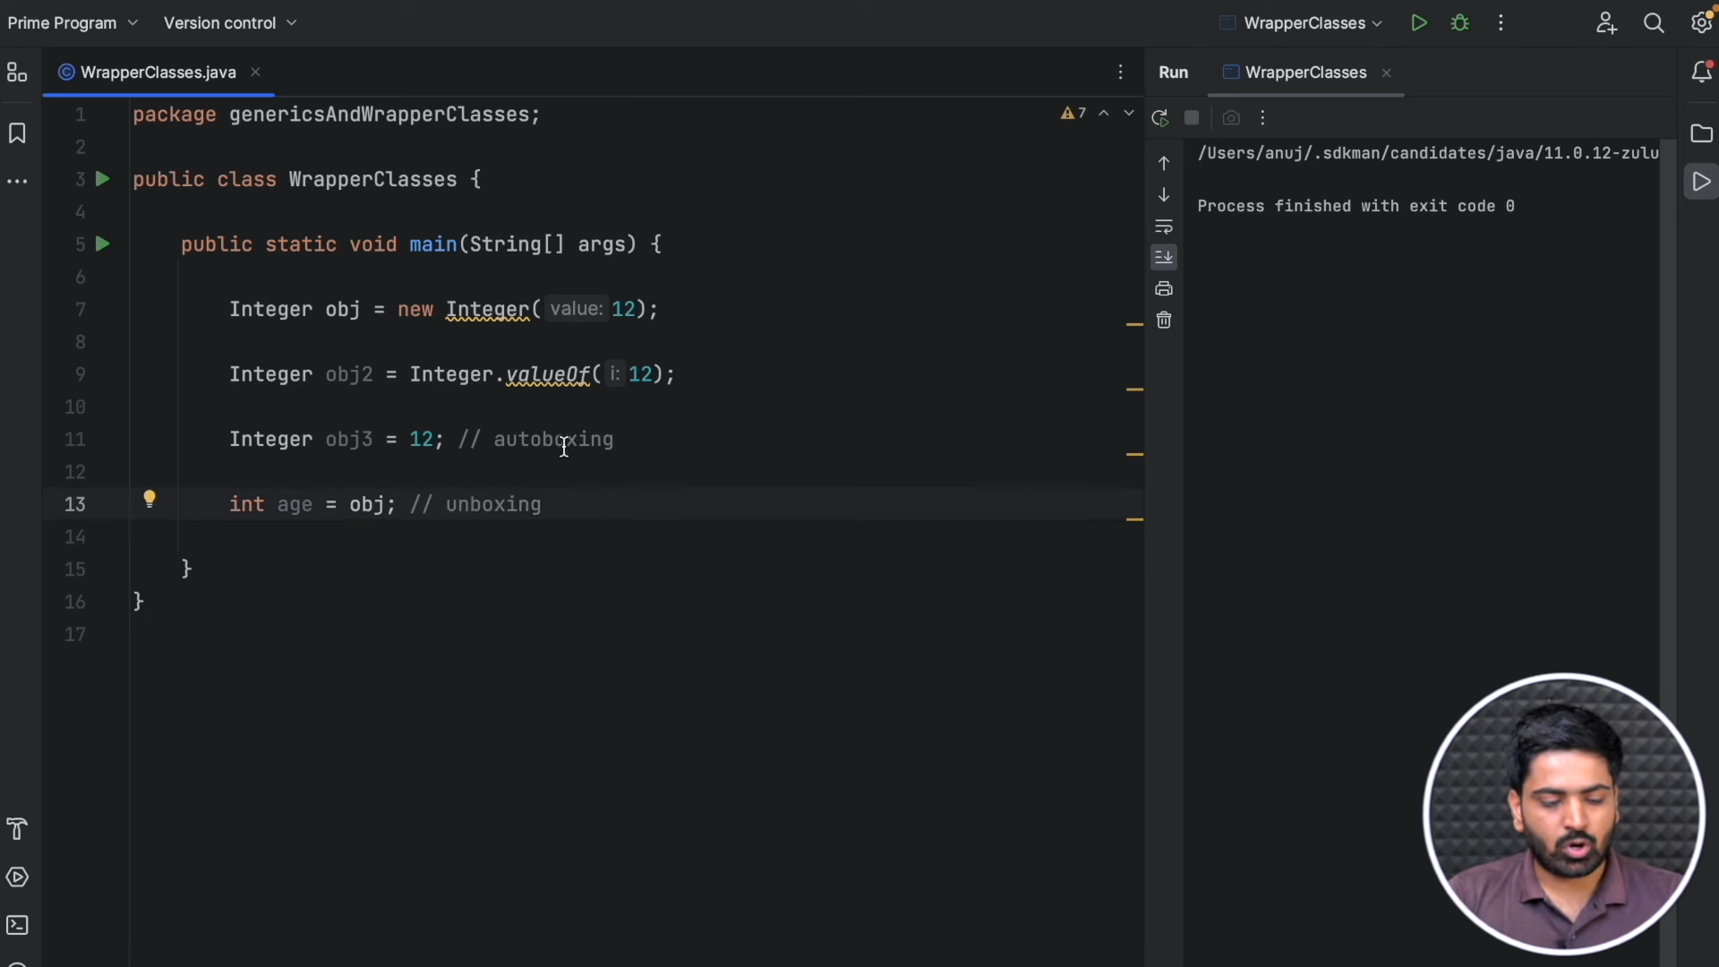

**Few other examples:**

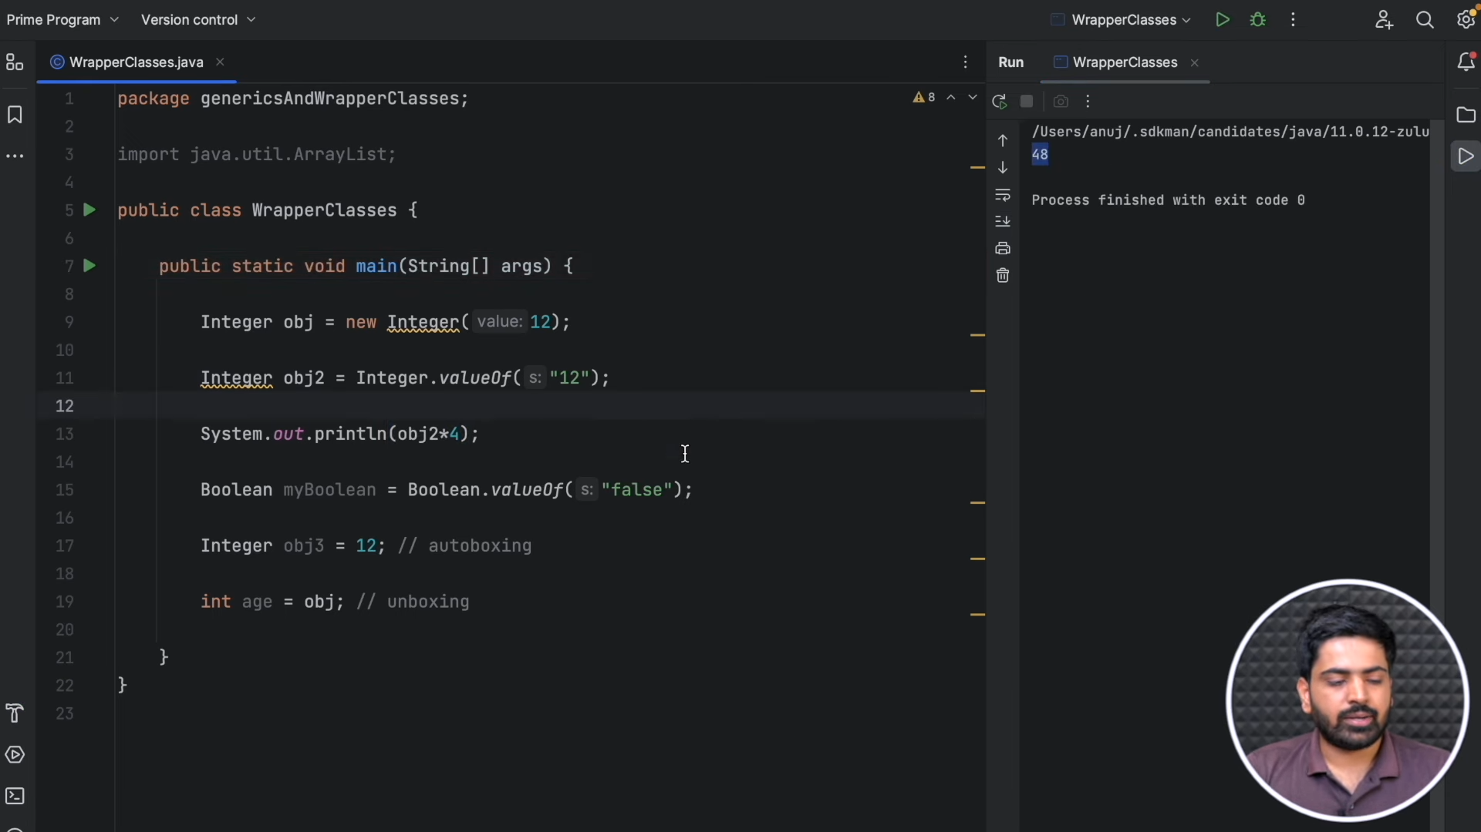

**Integer.valueOf() method converts string “12” into int, which then converted to Integer object referred by obj2.**

**When obj2 is used in the expression obj2 * 4, it is automatically unboxed to its primitive int value 12. The multiplication 12 * 4 is performed, resulting in 48.**

**Boolean.valueOf() method converts string “false” into boolean, which then converted to Boolean object referred by obj2.**